<Insert your company’s logo here. Apply your company’s branding (fonts, colors, illustration or
images) to the rest of the document as desired.>
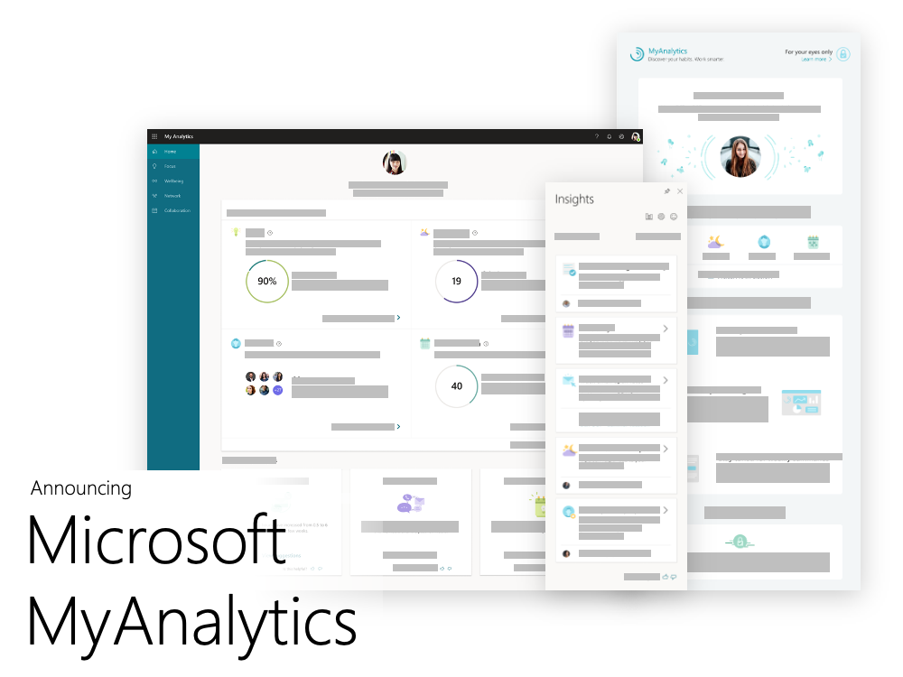
MyAnalytics is a Microsoft 365 application to help you find focus time, build your network, and improve your wellbeing. You’ll also get weekly summaries and inline suggestions directly in Outlook to support your goals.

See it in action
01  Watch the video to learn how MyAnalytics can work for you. |  | 02  Learn about the people and time insights MyAnalytics can provide.
For your eyes only
MyAnalytics is a personal, private tool for tracking your productivity at work.
Nobody in your organization can see your MyAnalytics data but you.
Timing and how to opt out
We will introduce MyAnalytics on <date>. You’ll see a Welcome email from MyAnalytics in your Outlook inbox. And then you’ll get access to your personal dashboard in Microsoft 365 and start getting weekly summaries.

If you prefer not to participate, email us at <email address>. You can also opt out of MyAnalytics at any time. Learn more here.
Your next steps
Join us on <date> for tips on getting started with
Microsoft MyAnalytics.
 | Share your questions or feedback. We’re here to help you. <Insert email alias or Teams group link, or customize this section with more information>

