TIP: You can edit and customize to include information specific about your company’s objectives, or with a logo or customer header and footer.
To: <Your organization’s group managers>
From: <Your Viva Insights admin >

Insights for People Managers
<Your organization> has worked with Microsoft Viva Insights to provide you key insights about your team’s collaboration effectiveness and employee experience. This is a first step in helping managers support their team’s wellbeing and productivity with meaningful and actionable insights.
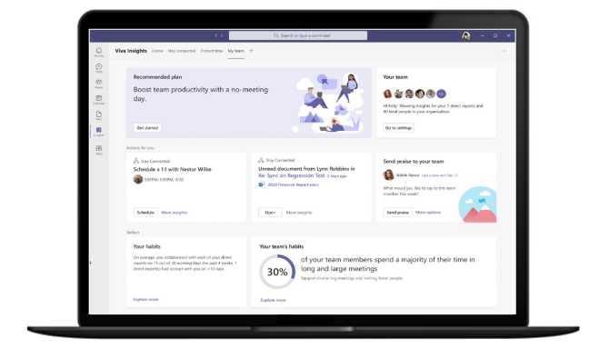
Insights are available in both the “My Team” tab of the new Viva Insights app in Teams or in the web experience at www.workplaceanalytics.office.com. You will maintain access to insights as long as you have at least nine people in your hierarchy.
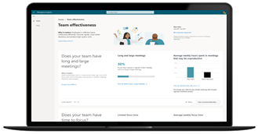

How do these insights help
Develop a culture of 1:1 coaching
See how much time team members spend one-on-one with their managers, and make sure it aligns with the culture you're striving for.
Improve meeting and email habits
Help your team reduce excessive meetings and improve email habits to support team effectiveness and productivity.
Support team wellbeing
Check on your team’s after-hours work habits and use these insights to balance schedule flexibility and the need to disconnect.
Cross-team collaboration
Review how your team is collaborating with the rest of the organization and reflect on how you can help expand the networks of your team.

Why is this important?

Managers have a huge impact on team productivity and wellbeing. Check out the research:
- Managers account for 70% variance in employee engagement scores. (Gallup)
- Employees tend to model their behaviors after their managers. (Microsoft Workplace Insights)
- Employees who regularly connect with their manager while working remotely are less impacted by increases in workday span and collaboration hours. (Microsoft Workplace Insights)
TIP: Customize with your organization’s objectives

Data and privacy

The Viva Insights app uses anonymized data from email, meetings, calls, and chats in Outlook and Teams to uncover insights about collaboration in your organization. Managers will only ever see aggregated data for their teams with no access to individual insights.

How to get started
- Visit the “My Team” tab in the Microsoft Viva Insights app in Teams or in the web experience at www.workplaceanalytics.office.com to begin reviewing your manager insights.
- <You communication channel for managers> for questions and guidance. Also see Manager insights FAQ.
TIP: Customize with program specifics

