<Insert your company’s logo here. Apply your company’s branding (fonts, colors, illustration or images) to the rest of the document as desired.>
Announcing Microsoft MyAnalytics
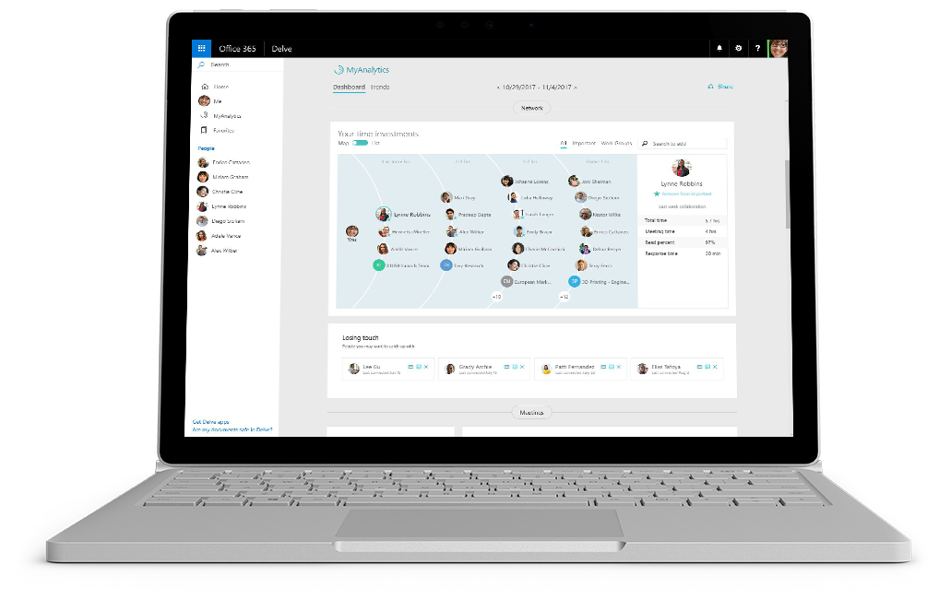
We’re excited to announce the introduction of a new Office 365 application called MyAnalytics.

MyAnalytics is best described as a “fitness tracker for the workplace.” It helps you understand how you spend your time at work and find ways to be more productive. You’ll get insight into how much high-quality focus time you get each week, how much you collaborate with coworkers after-hours, and much more. You’ll also get tips directly in Outlook to support your goals.

See it in action
Watch the video to see how MyAnalytics  can work for your organization |  | Learn more tips about  working with MyAnalytics
Personal, private insights
MyAnalytics is a personal, private tool for tracking your productivity at work.
Nobody in your organization can see your MyAnalytics data but you.

Timing and how to opt out
We will introduce MyAnalytics on <date>. You’ll receive a Welcome message from the application, then get access to a personal dashboard in Office 365 and receive a weekly summary email.

If you prefer not to participate, email us at <address>. You can also opt out of MyAnalytics at any time. Learn more here.

Your next steps
Join us on <fill in date> for tips on getting started with
Microsoft MyAnalytics.
 | Share your questions or feedback. We’re here to help you. <Insert email alias or Yammer group link, or customize this section with more information>

